**Expt4**

**Aim: Implementation of Association Rule Mining algorithm (Apriori in java/python).**

Theory:

In data mining, **Apriori** is a classic algorithm for learning association rules. Apriori is designed to operate on databases containing transactions (for example, collections of items bought by customers, or details of a website frequentation).

Other algorithms are designed for finding association rules in data having no transactions (Winepi and Minepi), or having no timestamps (DNA sequencing).

Overview

The whole point of the algorithm (and data mining, in general) is to extract useful information from large amounts of data. For example, the information that a customer who purchases a keyboard also tends to buy a mouse at the same time is acquired from the association rule below:

Support: The percentage of task-relevant data transactions for which the pattern is true.

Support (Keyboard -> Mouse) = AprioriAlgorithm/eq_1.JPG

Confidence: The measure of certainty or trustworthiness associated with each discovered pattern.

Confidence (Keyboard -> Mouse) = AprioriAlgorithm/eq_2.JPG

The algorithm aims to find the rules which satisfy both a minimum support threshold and a minimum confidence threshold (Strong Rules).

* Item: article in the basket.
* Itemset: a group of items purchased together in a single transaction.

How Apriori Works

1. Find all frequent itemsets:
   * Get frequent items:
     + Items whose occurrence in database is greater than or equal to the min.support threshold.
   * Get frequent itemsets:
     + Generate candidates from frequent items.
     + Prune the results to find the frequent itemsets.
2. Generate strong association rules from frequent itemsets
   * Rules which satisfy the min.support and min.confidence threshold.

High Level Design

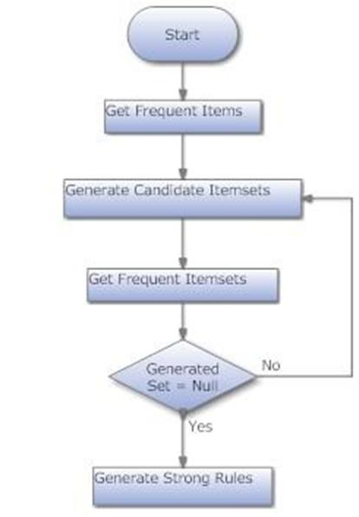

Low Level Design

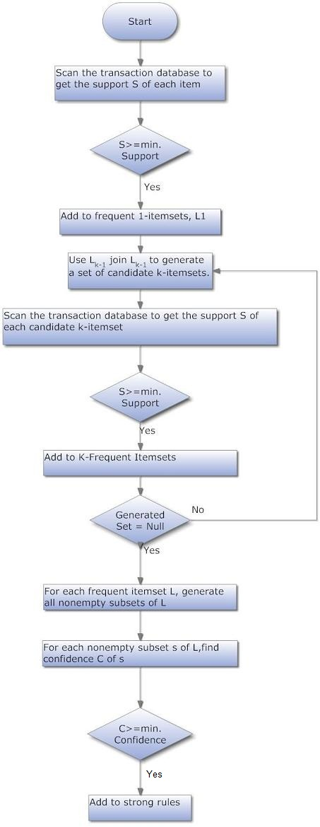

Example

A database has five transactions. Let the min sup = 50% and min con f = 80%.

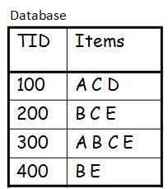

Solution

Step 1: Find all Frequent Itemsets

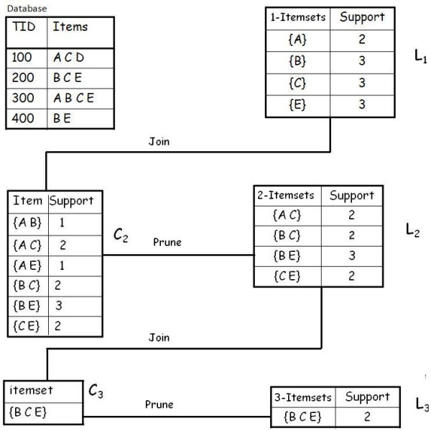

**Frequent Itemsets**

Hide   Copy Code

{A} {B} {C} {E} {A C} {B C} {B E} {C E} {B C E}

Step 2: Generate strong association rules from the frequent itemsets

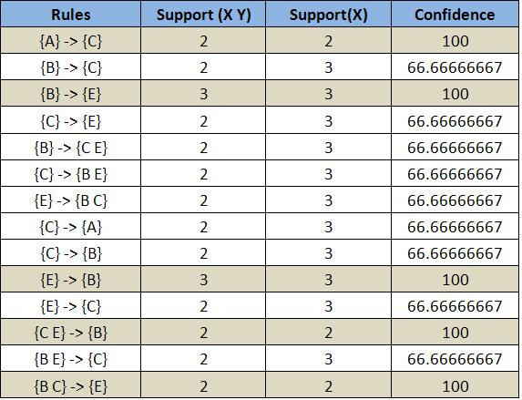

Lattice

**Closed Itemset**: support of all parents are not equal to the support of the itemset.

**Maximal Itemset**: all parents of that itemset must be infrequent.

**Keep in mind**:

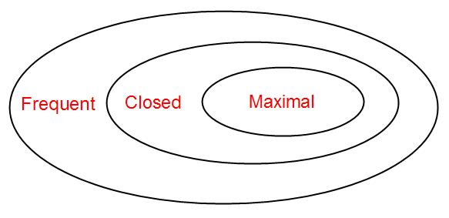

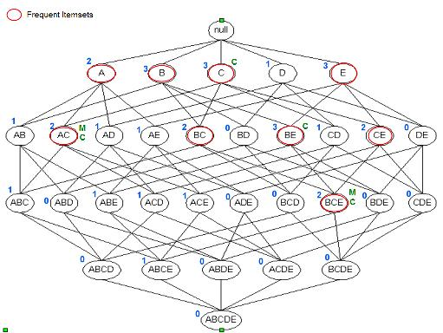

Itemset {c} is closed as support of parents (supersets) {A C}:2, {B C}:2, {C D}:1, {C E}:2 not equal support of {c}:3.

And the same for {A C}, {B E} & {B C E}.

Itemset {A C} is maximal as all parents (supersets) {A B C}, {A C D}, {A C E} are infrequent.

And the same for {B C E

**Post lab:**

1) Give limitations of Apriori algorithms

2) Write different variations of FP tree algorithm

3)Explain FP tree Algorithms with one example